Commercial facilities services STATEMENT of QUALIFICATIONS

Headquartered in Roseville, California, PRIDE Industries One, Inc. (PRIDE) is the largest nonprofit facilities maintenance provider in the nation. We provide a portfolio of diverse services for municipal, federal, and commercial sector customers varying in size from small start-ups to Fortune 500 companies.

As a social enterprise and one of the largest employers of people with disabilities or barriers to employment, PRIDE is much more than just a commercial facilities service (CFS) contractor. We provide contracting solutions that help make a difference in our customers’ organizations and their communities. Our portfolio of services is customized to meet the needs of all of our customers nationwide; whether in commercial or federal sectors, our single focus is to ensure our services are aligned with keeping our customers competitive in their respective markets.

With our focus on high quality service combined with our core commitments to environmental and social sustainability, PRIDE is a truly exceptional organization, with priorities and services as unique as our mission. For over 50 years, PRIDE has provided preventive maintenance services for clients throughout the California region and all over the country. Our local team most notably serves the Judicial Council of California and the Courts throughout Northern California, as well as other state and local municipalities. Our qualifications reflect a knowledgeable and dedicated technical team with extensive experience maintaining a variety of facilities both locally and across the nation.

# Integrated Facilities Services

PRIDE combines facilities expertise, comprehensive maintenance programs, and solutions-oriented management for reliable results that protect all types of facilities, from public and private sector to industrial and high-tech industries.

Our IFS division maintains a diversified, $201M portfolio of over 100 facilities management (FM) contracts including operations and maintenance (O&M), custodial services, grounds maintenance, base operations support, civil engineering, transportation, warehousing, logistics, and shipboard provisioning contracts. Our team is currently providing services at over 12,000 buildings across the nation, encompassing 3 million acres of land and more than 77.8 million square feet of facilities. Over 3.6 million square feet of these facilities are LEED-compliant, including LEED Platinum-Certification.

PRIDE brings built-in, added value to our customer based on our proven track record of performance with respect to the operations, repair, preventive maintenance, and facilities upgrades of municipal and government-owned facilities across the United States including some of the nation’s largest military installations, universities, and city, county, and state customers. Our integrated facilities services include:

* Facilities Management
* Asset Management
* Custodial Services
* Operations and Maintenance
* Project Management
* Job Order Contracting
* Work Order Management
* Civil Engineering
* Construction Improvements
* Utilities Management
* Waste Treatment Management
* Housing Maintenance
* Preventive and Predictive Maintenance
* HVAC/Mechanical
* Electrical
* Plumbing
* Solar/Energy Systems Maintenance
* Building Automation Systems and Controls
* Fire Suppression Systems
* Emergency Generator Maintenance and Compliance
* Uninterruptible Power System (UPS) Maintenance
* Capital Equipment Analysis & Planning
* 24/7/365 Customer Service Call Center
* Supplier/Vendor Management
* Grounds and Landscaping
* Energy Management Systems and Audit
* Environmental Health and Safety
* Waste Reduction Programs
* Net-Zero Initiatives
* Lamp Replacement/Lighting Retrofits
* Pest Control
* Cost Benefits Analysis and Reporting

## IFS Contract Experience

PRIDE has a wealth of Single Award Task Order Contract (SATOC), Job Order Contracting (JOC), and Indefinite Delivery Indefinite Quantity (IDIQ) experience that includes project design, planning, estimating, scheduling, and subcontractor bid package preparation including numerous other tasks. PRIDE’s unique blend of JOC and SATOC contracting experience, combined with facilities operations and maintenance experience, has resulted in project management competencies tailored for a fast-paced, multiple small project environment. PRIDE has a unique understanding of tenant, engineering, and maintenance stakeholder requirements. In addition, PRIDE performs all craft and task work at numerous DOD locations. Based on our experience, PRIDE brings knowledge of the specific nuances required to be successful in any environment.

# Technical capabilities

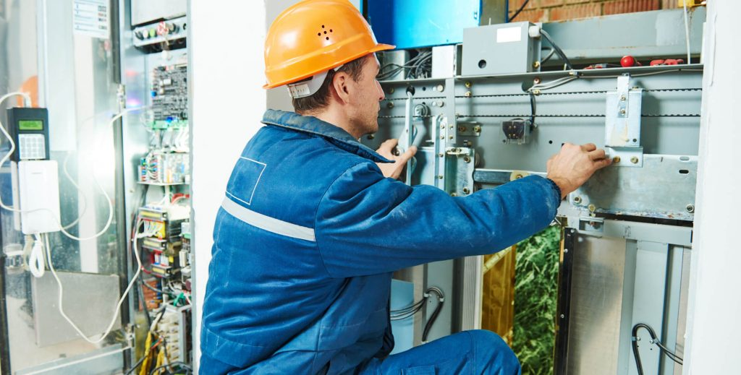PRIDE maintains 12 valuable Contractor State License Board (CSLB) license classifications. This enables our team to be readily prepared to provide any expansion of service that may arise due to an equipment failure or equipment replacement project with the appropriate licensing for the myriad of scopes that support such projects.

Along with PRIDE’s unwavering commitment to our social mission, we bring the most skilled tradesmen in the facility operations and maintenance industry, leading asset management practices, ingrained capital planning value added services, and expandability.

All of PRIDE’s technicians are members of the International Union of Operating Engineers (I.U.O.E) Local 39. Local 39 provides best-in-class trade training, as well as vital continuing education to all its members, ensuring technicians remain up to date on all evolving building systems technology and regulations.

PRIDE is fully committed to employing the best asset management practices possible. This is done by first ensuring all customer assets under our scope are properly identified and captured within our Computerized Maintenance Management System (CMMS), which serves as the foundation for our service delivery.

We then perform condition assessments on equipment and document each piece’s current condition, location of equipment, and where they reside in their anticipated lifecycle. Based on this data, we develop anticipated replacement costs, and forecast capital planning needs for equipment replacement based on criticality, equipment performance and history, energy efficiency, and other business case requirements. Additionally, every service event PRIDE has will be tracked down to the asset level, enabling us to provide cradle-to-grave analysis of where dollars are being spent on the equipment.

Throughout PRIDE’s portfolio of facilities programs, we are charged with inspecting, testing, operating, and maintaining all the major systems in modern facilities. Our service delivery is administered through a mix of proper licensing, strong technical program management, and highly skilled and trained field technicians experienced in the following disciplines:

* Operations & Maintenance (O&M) Services
* Construction Services
* Heating, Ventilation, and Air Conditioning (HVAC) Services
* Solar and Renewable Energy Services
* Electrical Services
* Engineering Services
* Plumbing Services
* Fire Systems Safety Services

## Licenses

PRIDE maintains several Contractor State License Board (CSLB) license classifications that enable our team to provide any expansion of service that may arise during the course of a contract. To follow is a comprehensive list of contractor licenses that PRIDE’s CFS division maintains with the CSLB.

|  |
| --- |
| **CALIFORNIA STATE LICENSING BOARD** |
| **Class** |
| * A: General Engineering |
| * B: General Building |
| * C4: Boiler |
| * C7: Low Voltage Systems |
| * C10: Electrical (including Generator Load Bank Testing) |
| * C16: Fire Protection |
| * C20: Warm-Air Heating, Ventilation & Air Conditioning |
| * C27: Landscaping |
| * C36: Plumbing (including Back Flow Preventer Testing and Certification) |
| * C38: Refrigeration |
| * C43: Sheet Metal |
| * C46: Solar |

## Operations and Maintenance (O&M) Service Experience

PRIDE is a significant contributor to the facilities O&M market; servicing over 12,000 facilities and 84 MSF nationwide. We have developed strong program management and integration disciplines that help us to leverage our national position to better understand and service a variety of facility environments. By promoting best practices, lessons learned, data and analytics, innovation, and connective business systems, PRIDE can provide facilities solutions that have a base of knowledge beyond the Placer County portfolio.

PRIDE brings built-in, added value to our customers based on our proven record of performance with respect to the operations, repair, preventive maintenance, and facilities upgrades of government-owned facilities across the U.S. including some of the nation’s largest military installations, universities, city, county, and state customers. PRIDE’s experience with round-the-clock service delivery spans 25 years of experience in 24/7, 365-day continuous use environments.

Though PRIDE holds a significant national presence, our presence in California represents nearly half of our total market share. PRIDE holds a portfolio of work totaling nearly $108M/year and 36 MSF within the state. Our geographic and managerial presence ranges from the Oregon border to San Diego in Southern California. Additionally, PRIDE CFS has a growth strategy that will serve to strengthen the depth of expertise and market staying power that benefits Placer County. With this presence comes an experienced, educated, and credentialed staff that can assure successful program delivery.

### Experienced O&M Staff

PRIDE CFS also delivers best-in-class service delivery through a commitment to having the best trained and experienced building engineers in the industry. As an employer to over 1,000 specialized O&M staff in diverse labor categories, PRIDE has reach back to staff who are available to provide service, backfill vacancies, and perform troubleshooting if needed. We do this by partnering with the AFL-CIO International Union of Operating Engineers. PRIDE’s operating companies are signatory to the Local 39 in Northern California and Local 501 in Southern California. This partnership allows us to recruit and retain the best trained building engineers in the industry and allows us to ensure a pathway to continuing education in the building sciences that serves an evolving and changing portfolio. Likewise, PRIDE CFS possesses one of the most extensive lists of specialized trade classifications with the California Contractors State License Board (CLSB) of any contractor in the state, and of any of the other offerors for the JCC portfolio(s). This allows us to provide specialized trade service offerings throughout the state and helps to reinforce the integrated trade specialists that support the building engineers on complex, time consuming, and specialized elements of work. Where in-house performance is not possible or practical, PRIDE CFS has strategically partnered with service partners that can complete and enhance our service delivery.

Also, due to our wide-spread facilities services offering throughout the state, we can provide operations management and subject matter experts at the best value, while ensuring that we have the right resources available to maximize service and program delivery. PRIDE’s CFS team is not only prepared, qualified, and best positioned to provide continuing service to Placer County but we are strategically aligned and prepared to deliver excellent, high-performing service. We have a unique perspective not only on the requirements and demands of Placer County but also the requirements, constraints, and demands for the various projects around the county. Between our similar experience, our diverse lines of service throughout the state, our program management disciplines, and our experience, PRIDE CFS brings to Placer County the expertise and power of a national firm, with the touch points and social impact of a trusted local vendor.

## Heating, Ventilation, and Air Conditioning (HVAC) Service Experience

A listing of PRIDE’s relevant, specialized HVAC experience is shown in the following table:

|  |  |  |
| --- | --- | --- |
| **SUMMARY OF PRIDE’S HVAC EXPERIENCE** | | |
| **Name of Project/ Project Title** | **Location** | **Total Value of Project** |
| HVAC - Replace Failed VAV Controllers (22 units) and Replace Failed BAS | Johnson Building Courthouse, S. Lake Tahoe, CA | $362,902.64 |
| Upgrade/Modernize In-Custody Elevator | Modesto Main Courthouse, Modesto, CA | $230,466.53 |
| HVAC - Remove and Replace Cooling Towers | Fresno County Courthouse, Fresno, CA | $217,673.56 |
| Remove and Replace 188 Courtroom Audience Seating | Butte County Courthouse, Oroville, CA | $112,317.20 |
| Emergency Response to Flooding of Wastewater in Public and Staff Restrooms | B.F. Sisk Federal Courthouse, Fresno, CA | $126,490.65 |
| HVAC - Replace Two Existing 975K BTU Boilers | Carol Miller Courthouse, Sacramento CA | $143,437.68 |
| Roof Replacement/46-A1 Roof Replacement | Sierra Co. Courthouse/Sheriff Station-Jail, Downieville, CA | $315,000.00 |
| Restore Exterior Building Shell | New Downtown Merced Courthouse, Merced, CA | $123,378.89 |
| Complete (2) Elevator System Renovations | Johnson Building Courthouse, S. Lake Tahoe, CA | $385,000.00 |
| Placerville Jail Boiler Replacement | Placerville County Jail, Placerville, CA | $209,915.88 |
| Placerville Library ADA New Ceiling Framing for All Restrooms | Placerville Library, Placerville, CA | $145,968.55 |
| Auburn Justice Center Interior/Exterior Repairs | Auburn, CA | $145,278.76 |
| Hidden Falls Parking Lot Expansion | Hidden Falls Park, Auburn, CA | $204,423.84 |
| Public Works Boiler Replacement | Hazelton Complex, Stockton, CA | $173,987.22 |

### Experienced HVAC Staff

PRIDE employs service HVAC technicians that have more detailed training and experience than that of a building engineer. HVAC technicians are equipped, trained, experienced, and prepared to handle those situations that move beyond normal troubleshooting and maintenance into advanced troubleshooting, major maintenance, and repair, up to and including replacement. We enhance the training requirements of our technicians serving in the HVAC classification to include specific manufacturer training for HVAC systems maintained throughout our contracts. To date, we have HVAC technicians trained by the following manufacturers:

* Johnson/York
* Carrier
* Trane
* EcoLabs
* Diakin/McQuay

## Solar and Renewable Energy Service Experience

A listing of PRIDE’s solar photovoltaic experience is shown in the following table:

|  |  |
| --- | --- |
| **SUMMARY OF PRIDE’S SOLAR EXPERIENCE** | |
| **Name of Project/ Project Title** | **Location** |
| Judicial Council of California | Northern California Region |
| Judicial Council of California | New Hanford County Court House  Hanford, CA |
| Judicial Council of California | New San Andreas Court House  San Andreas, CA |
| Miller Brothers Seabrook Farms Solar Facility 1 & 2 | Cumberland County, NJ |

### Solar Project Descriptions

To follow are examples of PRIDE’s past contract sites that have involved the delivery of solar maintenance and repair services.

#### Judicial Council of California, Northern California

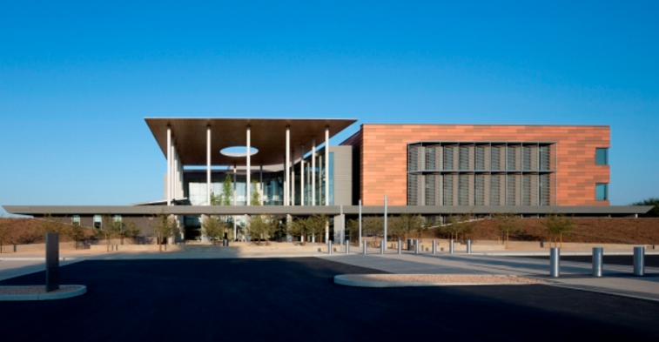PRIDE provides the Judicial Council of California (JCC) operations and maintenance services for all Northern California court houses from Fresno to the Oregon border. In addition to the operations and maintenance services, PRIDE also services their solar photovoltaic, thermal hot water, generators, including their load bank testing of the generators and ups systems. There are a total of 59 courts in our JCC portfolio where we maintain MEP (mechanical, electrical, plumbing) systems and landscaping. Cloves Tennis and Don Lucy are both integral team members, serving as district managers who support the overall management of the JCC contract.

#### New Hanford County Court House

Within our JCC contract throughout California, PRIDE also performs semi-annual inspections and maintenance for a 1.0-megawatt photovoltaic carport mount system, including necessary maintenance for all inverters, strings, and modules at Hanford County Court House. Maintenance deliverables were completed licensed journeyman electricians, William “Skip” McGoldrick and Tyler Lyndsey.

#### New San Andreas Court House

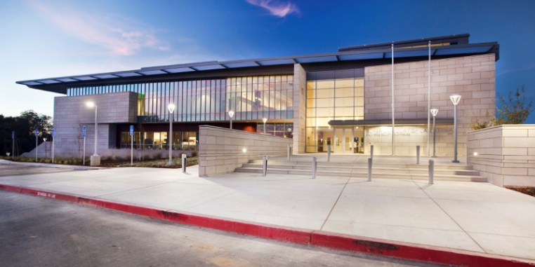Calaveras County Court House is another notable project within PRIDE’s JCC operations and maintenance service contract. PRIDE delivered semi-annual inspection and maintenance for .8 megawatt photovoltaic roof mount system, including the inverters strings and modules. Serviced by William “Skip” McGoldrick Licensed Journeyman Electrician. and Tyler Lyndsey Licensed Journeyman Electrician.

#### Miller Brothers Seabrook Farms Solar Facility 1 & 2

PRIDE has also executed annual maintenance services for Miller Brothers at Seabrook Farms Solar Facilities 1 & 2 in Seabrook, New Jersey. These services included maintenance of a 4.3 megawatt photovoltaic ground mount system, as well as all required inverters, strings, modules, and transformers. Services were provided by Tyler Lyndsey, a licensed journeyman electrician and Don Brown, solar technician and building maintenance technician.